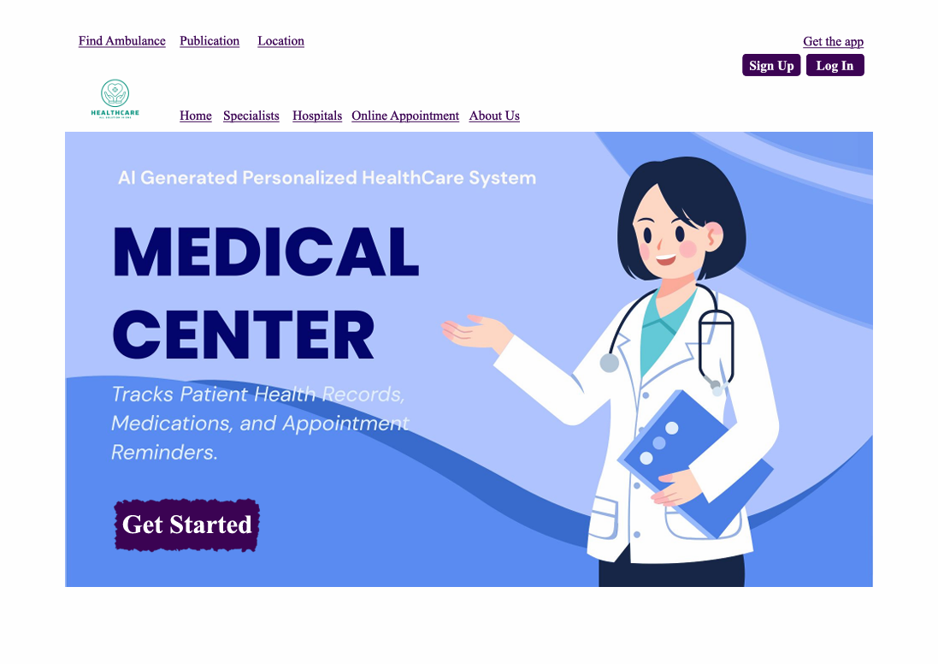

1. Home Page
Description:
This is the first page users see. It gives quick access to important healthcare services like finding an ambulance, finding a hospital, and booking an appointment. At the top, there are helpful buttons like About Us, Specialists, and Get the App. The logo can also be clicked to go back to this page. There are also Sign Up, Log In, and Get Started buttons to help users begin using the app. Everything is simple and easy to find.

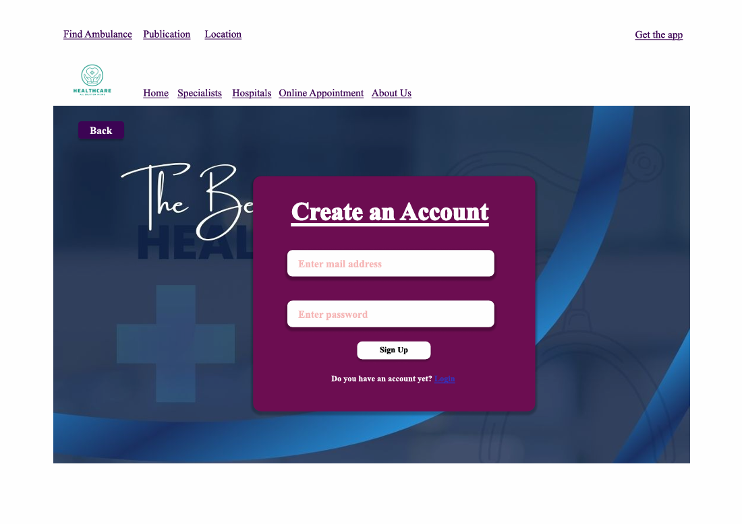

2. Sign-Up Page
Description:
This page is for new users to make an account. They just need to enter their email and password. If they already have an account, there's a message that tells them to go to the login page instead. There's also a back button to return to the last page. The top buttons are the same as on the home page.

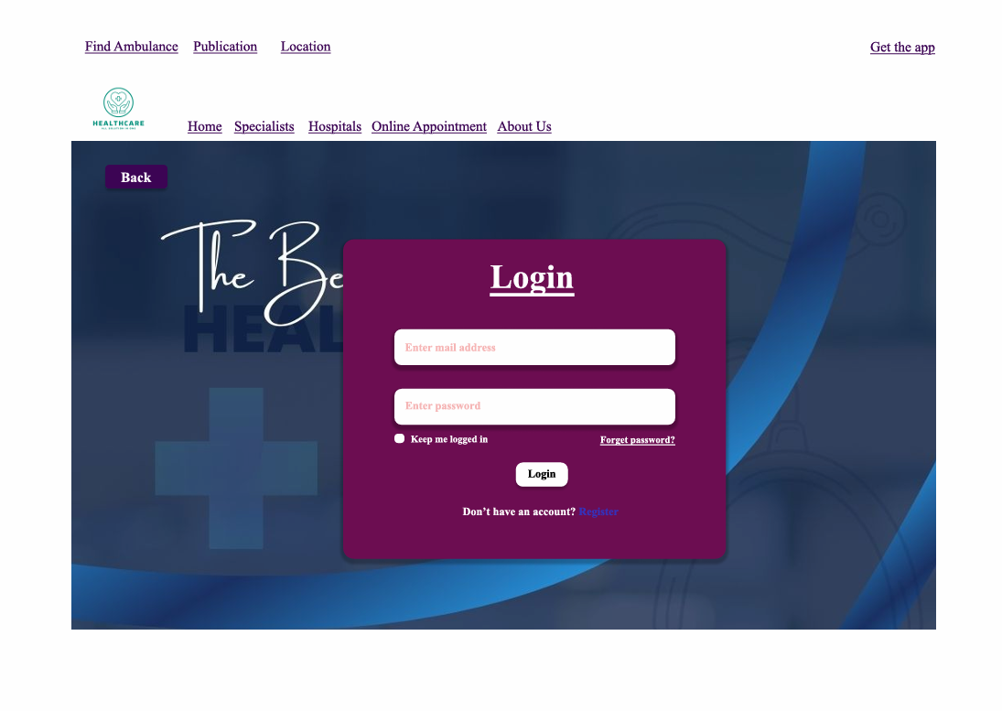

3. Login Page
Description:
This page lets users who already have an account log in by entering their email and password. It also has extra options like “Forget password?” and “Keep me logged in.” If users don’t have an account, there’s a link to go to the sign-up page. The top buttons are the same as on the home page.

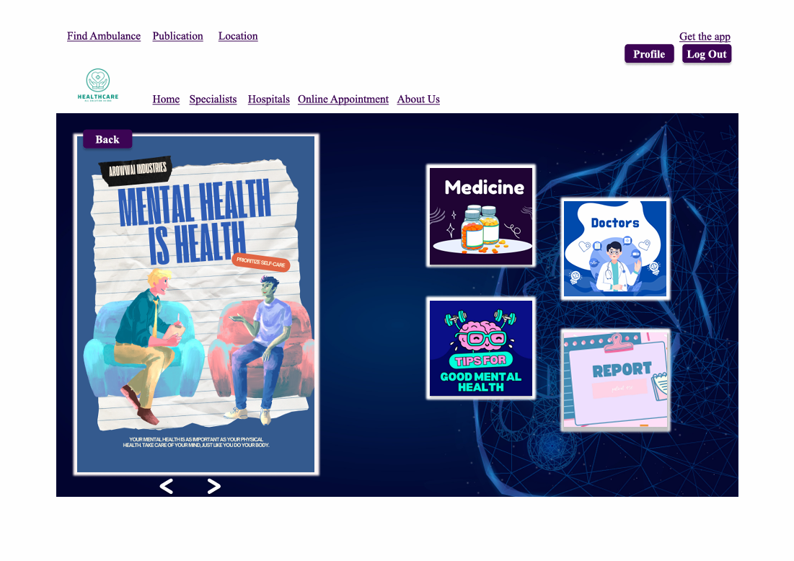

4. Profile Page
Description:
After logging in, users can see their personal profile. From here, they can check their health records, medicine list, saved doctors, and health tips. They can also manage their appointments. The page is simple and focuses on things the user needs. The top buttons are the same as on the home page.

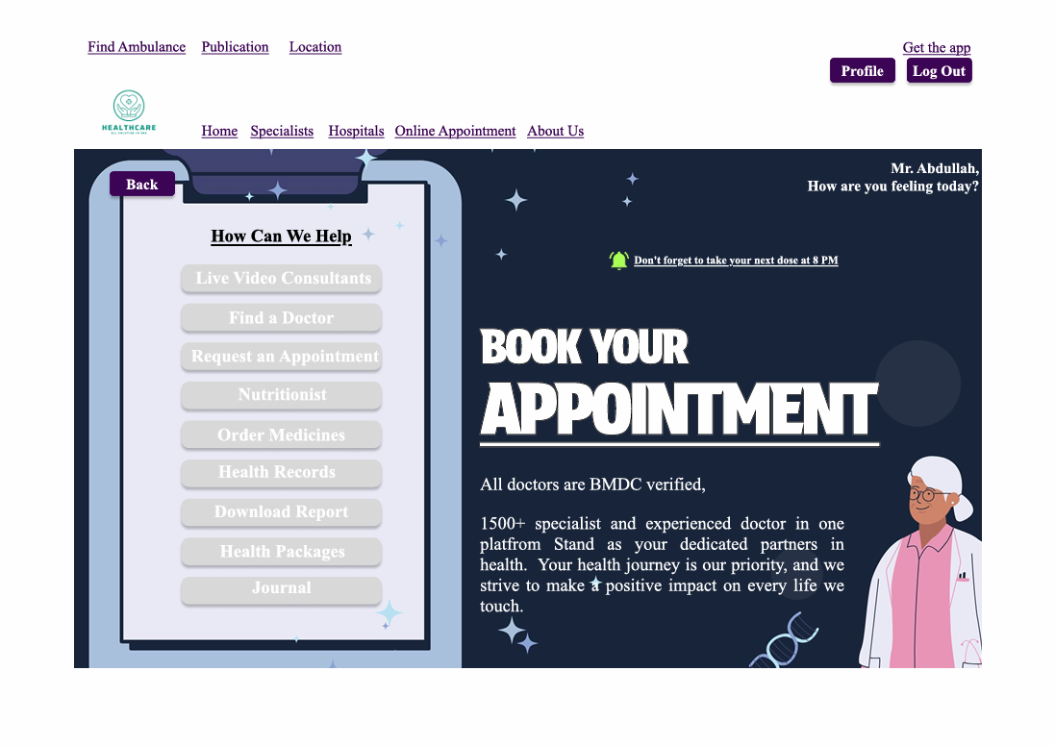
5. Dashboard
Description:
This page greets the user by name (like “Mr. Abdullah, how are you feeling today?”). It reminds them to book an appointment and shows a section called How Can We Help with useful buttons like: Live Video Chat, Find Doctor, Nutritionist, Order Medicines, Health Records, Download Report and Journals. It also says that all doctors are BMDC-verified, which helps users trust the service. There is a small reminder like: “Don’t forget to take your next dose at 8 PM.” The top buttons are the same as on the home page.
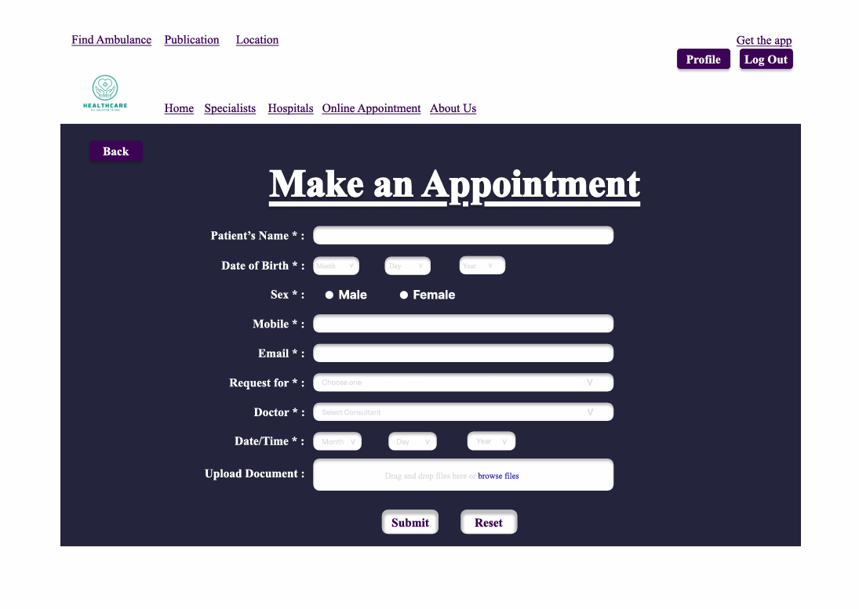

6. Appointment Booking Page
Description:
This page helps users book an appointment. It has a form where users fill in their name, date of birth, gender, phone number, email, and the doctor they want to see. They can choose a date and time, and also upload documents. There are Submit and Reset buttons at the bottom. The top buttons are the same as on the home page.
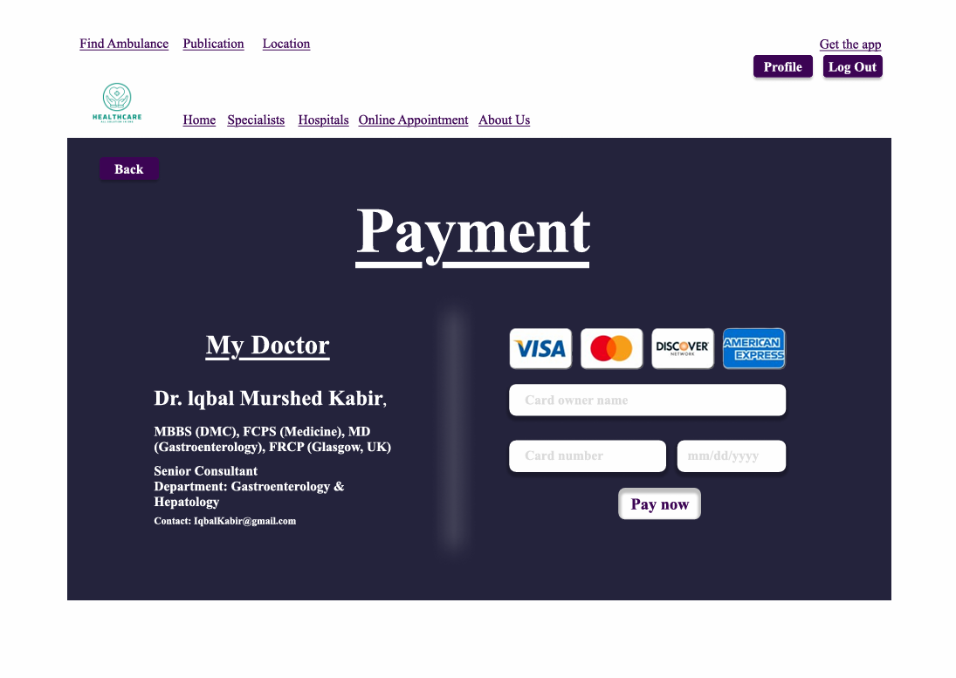

8. Payment Page
Description:
This page is for making payments. Users enter their card number, cardholder name, and expiration date, then click a Pay Now button. There is also a section called My Doctor which shows the doctor’s name, degrees, department, and contact email. The top buttons are the same as on the home page.
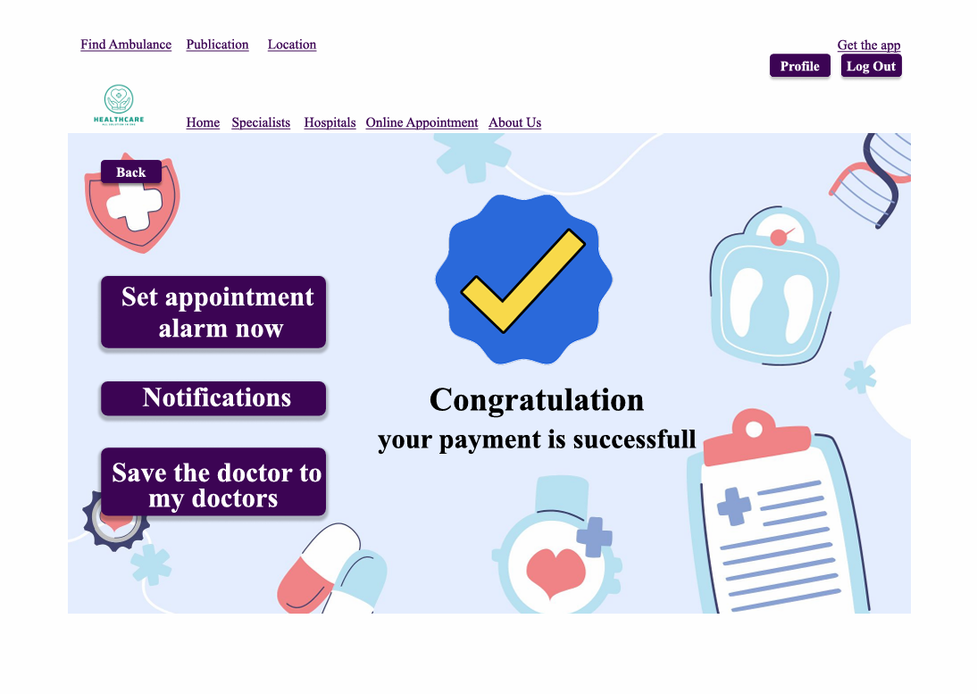

9. Confirmation Page
Description:
After finishing a payment or booking, this page shows a message like: “Congratulations, your payment is successful.” It lets the user know everything went well. There are three buttons on this page: Set Appointment Alarm, Notifications and Save the Doctor to My Doctors. The top buttons are the same as on the home page.
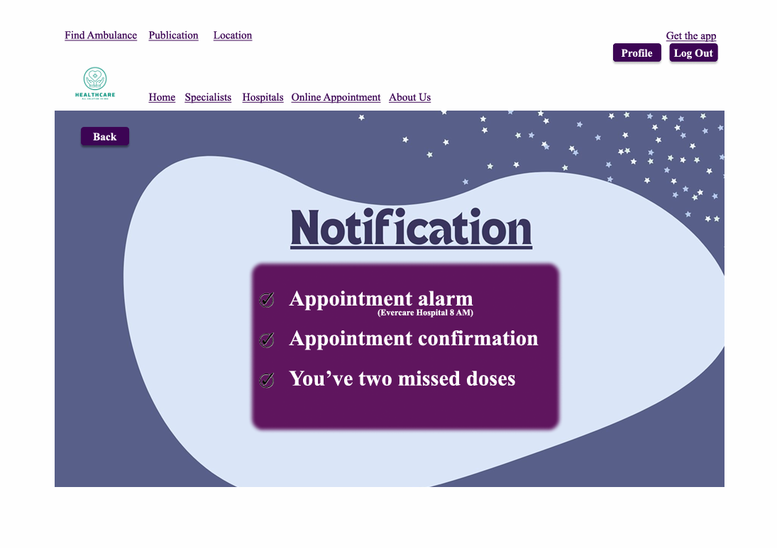
10. Notifications Page
Description:
This page shows reminders and alerts. For example, it might say: “Don’t forget to take your next dose at 8 PM,” or show alarms for upcoming appointments. It helps users stay on track with their health. The top buttons are the same as on the home page.

